**LP2 (Test on Edge Browser)**

**1.Verify the Header-**

(a) Logo should redirect to the correct link.

In this given website logo is not Working

(b) Logo link should open in a new tab.

It Is not open in the new tab as well as it is also not working.



**2.Verify the Footer-**

(a) Verify redirection of Links and content.

The redirection of the links and contents is not working. When we click on the content and link, they simply redirect to the top of the same webpage again and again.

(b) Verify social icons' redirection.

No social icons are there. Add the social icons at the footer.



**3.Verify Correct Favicon- Favicon should be the same as it is on the client's live website.**

No Faicon is there on the webpage.

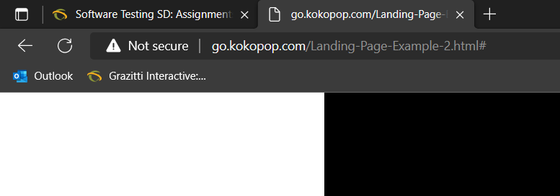

**4.Verify the Font-family- Verify font family is consistent throughout(unless special   requirement by client).**

In this screenshot the paragraph alignment is not correct

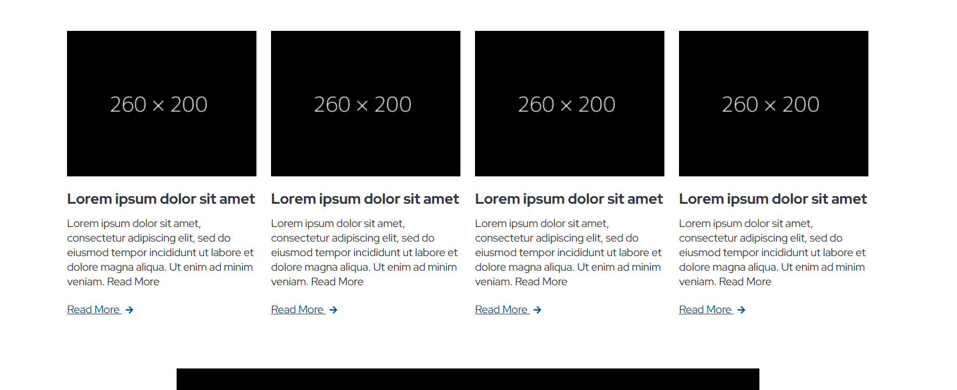

**5.Verify the redirection of links-**

(a) All CTAs, links and icons should redirect to correct pages.

Links is not working redirect to given pages only.

(b) Add note to developer if # is used for links.

Remove all # from the CTA links. ‘#’ is shown at last of every link.

**6.Verify the Spacing - Verify Spacing and alignment of the page should not break.**

In this snapshot there is an spacing which is breaking the page and create the bad impact on the website.

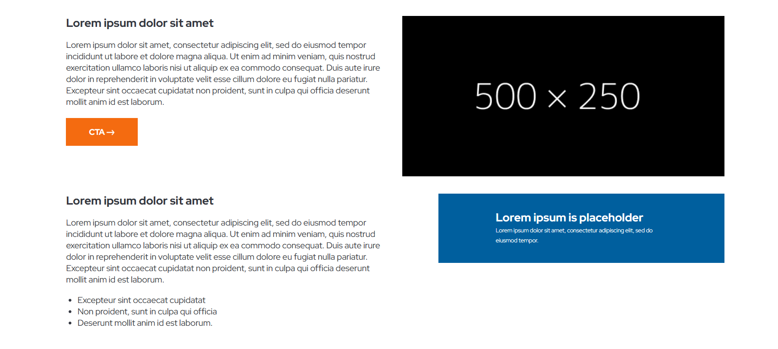

**7.Verify Form-**

(a) Verify alignment and spacing of form.

(b) Verify * is used for Mandatory Fields.

(c) Verify it is showing correct error messages.

In given website there is no form.

**8.Verify Thank you message after submitting form- If Required.**

In given webpage there is no form.

**9.Verify Landing page on cross browsers- Google Chrome, Firefox, Internet Explorer and MAC (Safari).**

On Google, Edge, Firebox and Chrome is working fine.

**10.Verify Responsive- Verify it on iPhone and iPad on simulator or live device.**